1.
import java.util.ArrayList;
import java.util.Iterator;
import java.util.List;

public class FloatAddition {
public static void main(String[] args) {
float sum = 0.0f;
List<Float> list = new ArrayList<Float>();
list.add(2.2f);
list.add(3.2f);
list.add(4.2f);
list.add(5.2f);
list.add(6.2f);
Iterator<Float> iter = list.iterator();
while (iter.hasNext()){
sum+=iter.next();
}
System.out.println(sum);
}
}
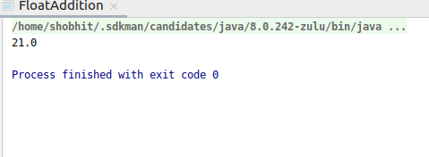

2.
import java.util.ArrayList;
import java.util.Iterator;
import java.util.LinkedHashSet;
import java.util.List;

public class UniqueChar {
public static void main(String[] args) {
String str = new String("Hello This is Java");
int counter;
UniqueChar uc = new UniqueChar();
counter = uc.charCount(str);
System.out.println("Unique characters in "+str+" are: "+counter);
}
public int charCount(String s){
int ctr = 1;
s=s.toLowerCase();
LinkedHashSet<Character> unique = new LinkedHashSet<>();
for (Character c: s.toCharArray()) {
unique.add(c);
}
return unique.size();
}
}
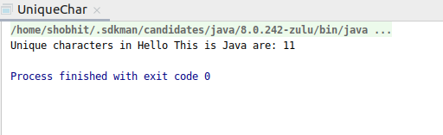

3.
import java.util.HashMap;
public class StringCharCount {
public static void occur(String str)
{
HashMap <Character, Integer> map = new HashMap<>();
for (int i =0 ; i < str.length(); i++)
{
if (map.containsKey(str.charAt(i)))
{
int count = map.get(str.charAt(i));
map.put(str.charAt(i), ++count);
}
else
{
map.put(str.charAt(i),1);
}
}
System.out.println(map);
}
public static void main(String[] args) {
String str = "This is java programming";
occur(str);}
}
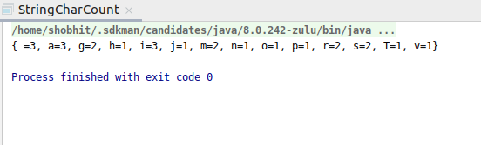

4.
import java.util.*;
import java.lang.*;

public class HashMapsort{

public static HashMap<String, Integer> sortByValue(HashMap<String, Integer> hm)
{
List<Map.Entry<String, Integer> > list =
new LinkedList<Map.Entry<String, Integer> >(hm.entrySet());

Collections.sort(list, new Comparator<Map.Entry<String, Integer> >() {
public int compare(Map.Entry<String, Integer> o1,
Map.Entry<String, Integer> o2)
{
return (o1.getValue()).compareTo(o2.getValue());
}
});

HashMap<String, Integer> temp = new LinkedHashMap<String, Integer>();
for (Map.Entry<String, Integer> aa : list) {
temp.put(aa.getKey(), aa.getValue());
}
return temp;
}

public static void main(String[] args)
{

HashMap<String, Integer> hm = new HashMap<String, Integer>();
hm.put("Rohan", 98);
hm.put("Sunny", 85);
hm.put("John", 91);
hm.put("Bob", 95);
hm.put("Alice", 79);
hm.put("Charlie", 80);
Map<String, Integer> hm1 = sortByValue(hm);

for (Map.Entry<String, Integer> en : hm1.entrySet()) {
System.out.println("Key = " + en.getKey() +
", Value = " + en.getValue());
}
}
}
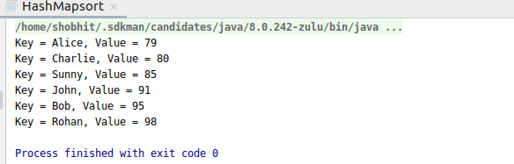

5.
import java.util.*;
class Employee
{
private double age;
private double salary;
private String name;
public Employee(double age,double salary,String name)
{
this.age=age;
this.name=name;
this.salary=salary;
}
public double getSalary() {
return salary;
}
@Override
public String toString() {
return "Employee{" +
"age=" + age +
", salary=" + salary +
", name='" + name + '\'' +
'}';
}
}
class SalarySorter implements Comparator<Employee>
{
@Override
public int compare(Employee t1, Employee t2) {
return (int) (t1.getSalary() - t2.getSalary());
}}
public class EmployeeSort {
public static void main(String[] args) {
Employee e1 = new Employee(45, 85600, "Alice");
Employee e2 = new Employee(22, 32000, "Bob");
Employee e3 = new Employee(43, 57000, "Mike");
Employee e4 = new Employee(20, 98200, "Peter");
Employee e5 = new Employee(23, 29200, "Clint");
List<Employee> employees = new ArrayList<Employee>();
employees.add(e5);
employees.add(e2);
employees.add(e1);
employees.add(e3);
employees.add(e4);
ListIterator<Employee> itr = employees.listIterator();
System.out.println("-------BEFORE SORTING-------");
while (itr.hasNext()) {
System.out.println("Value is : " + itr.next());
}
System.out.println();
Collections.sort(employees, Collections.reverseOrder(new SalarySorter()));
ListIterator<Employee> iterator = employees.listIterator();
System.out.println("-------AFTER SORTING--------");
while (iterator.hasNext()) {
System.out.println("Value is : " + iterator.next());
}
}
}
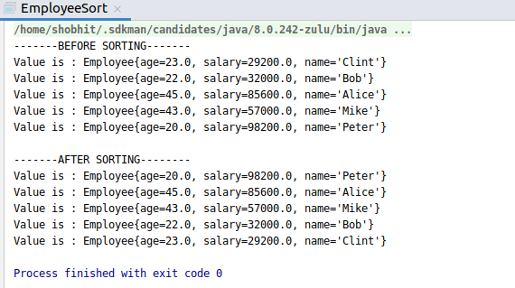

6.
import java.util.*;
class Student
{
private String name;
private int score;
private double age;
public Student(String name,int score,double age) {
this.name = name;
this.score = score;
this.age = age;
}
public String getName() {
return name;
}
public double getScore() {
return score;
}
@Override
public String toString() {
return "Student{" +
"name='" + name + '\'' +
", score=" + score +
", age=" + age +
'}';
}
}
class StudentSorted implements Comparator<Student>{
public int compare(Student t1, Student t2) {
// for comparison
int ScoreCompare = Double.compare(t1.getScore(), t2.getScore());
int NameCompare = t1.getName().compareTo(t2.getName());
// 2-level comparison using if-else block
if (ScoreCompare == 0) {
return ((NameCompare == 0) ? ScoreCompare : NameCompare);
} else {
return ScoreCompare;
}
}
}
public class StudentSort {
public static void main(String[] args) {
Student s1 = new Student("Alice", 99, 22);
Student s2 = new Student("Bob", 78, 20);
Student s3 = new Student("Aron", 80, 14);
Student s4 = new Student("Peter", 99, 19);
Student s5 = new Student("Sam", 80, 18);
List<Student> student = new ArrayList<Student>();
student.add(s1);
student.add(s2);
student.add(s3);
student.add(s4);
student.add(s5);
ListIterator<Student> itr = student.listIterator();
System.out.println("-------BEFORE SORTING-------");
while (itr.hasNext()) {
System.out.println("Value is : " + itr.next());
}
System.out.println();
Collections.sort(student, new StudentSorted());
ListIterator<Student> iterator = student.listIterator();
System.out.println("-------AFTER SORTING--------");
while (iterator.hasNext()) {
System.out.println("Value is : " + iterator.next());
}
}
}
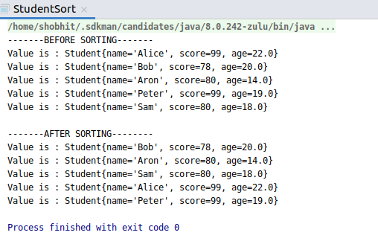

7.
import java.util.LinkedHashMap;
import java.util.Map;
public class FrequencySort {
public static void main(String[] args) {
int arr[] = {2, 5, 2, 6, -1, 9999999, 5, 8, 8, 8};
Map<Integer, Integer> countMap = new LinkedHashMap<>();
StringBuffer result = new StringBuffer();
for (int i = 0; i < arr.length; i++) {
if (countMap.containsKey(arr[i])) {
countMap.put(arr[i], countMap.get(arr[i]) + 1);
} else {
countMap.put(arr[i], 1);
}
}
System.out.println(countMap);
countMap.entrySet().stream().sorted(Map.Entry.<Integer, Integer>
comparingByValue().reversed())
.forEach(e -> {
int key = e.getKey();
int val = e.getValue();
for (int i = 0; i < val; i++) {
result.append(key + " ");
}
});
System.out.println("The Array sorted by frequency: " + result);
}
}
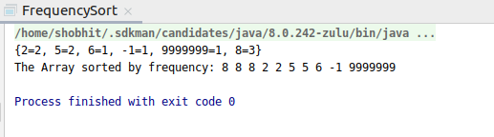

8.
import java.util.Stack;class myStack {
Stack<Integer> stack;
Integer minElement;
public myStack() {
stack = new Stack<Integer>();
}
public void peek() {
if (stack.isEmpty()) {
System.out.println("Stack is Empty ....");
}
Integer t = stack.peek();
if (t < minElement) {
System.out.println("Top most element is :" + minElement);
} else
System.out.println("Top most element is :" + t);
}
public void push(Integer i) {
if (stack.isEmpty()) {
minElement = i;
stack.push(i);
System.out.println("Element inserted :" + i);
return;
}
if (i < minElement) {
stack.push(2 * i - minElement);
minElement = i;
} else
stack.push(i);
System.out.println("Element inserted :" + i);
}
public void pop() {
if (stack.isEmpty()) {
System.out.println("Stack is empty, cannot pop an element");
return;
}
Integer t = stack.pop();
if (t < minElement) {
System.out.println("element removed :" + minElement);
minElement = 2 * minElement - t;
} else
System.out.println("element removed :" + t);
}
public void getMinElement() {
if (stack.isEmpty()) {
System.out.println("stack is empty..");
} else
System.out.println("min element is :" + minElement);
}
}
public class StackOpEx {
public static void main(String[] args) {
myStack stack = new myStack();
stack.getMinElement();
stack.pop();
stack.push(3);
stack.push(4);
stack.push(2);
stack.push(5);
stack.push(1);
stack.push(8);
stack.getMinElement();
stack.peek();
stack.pop();
stack.getMinElement();
stack.pop();
stack.getMinElement();
}
}
